

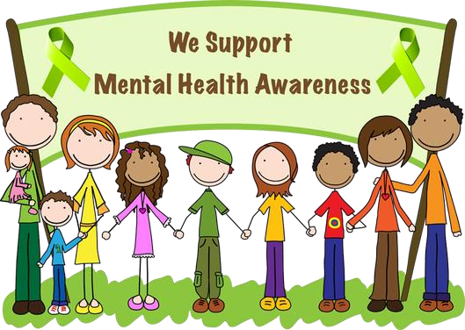
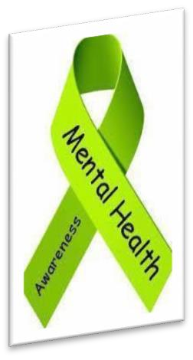
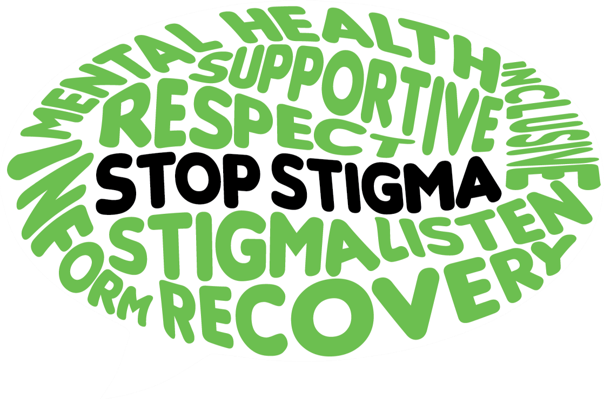
Join us for a drive through
e
event to increase awareness for
Mental Health and learn about

Available resources. Grab & Go information & treats!

This event is free

to all!!

Santee
-
Wateree Community

Mental Health Awareness Day

Stronger Than the Stigma

Friday,
May 14, 2021

am
11:00

–

22
:00
pm

Santee
-
Wateree CMHC

801
N. Pike West, Sumter, SC 29153

803
-
775
-
9364
Adult Services
•

803
-
775
-
7898
CAF Services

Wear Green to show your support
!

